**Appendix**

1. Linear Regression / OLS Code

a. Spending Score vs Loyalty Points

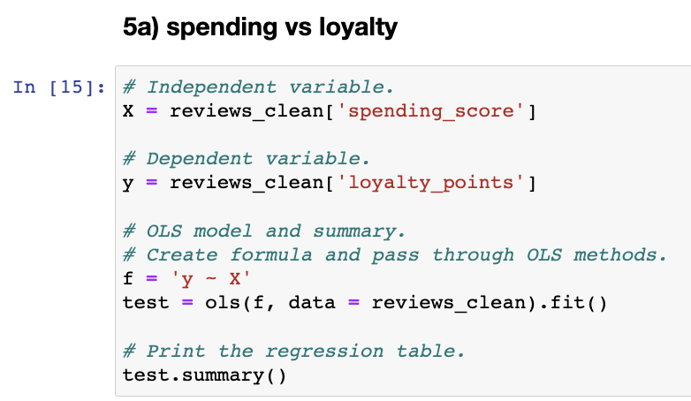

b. Remuneration vs Loyalty Points

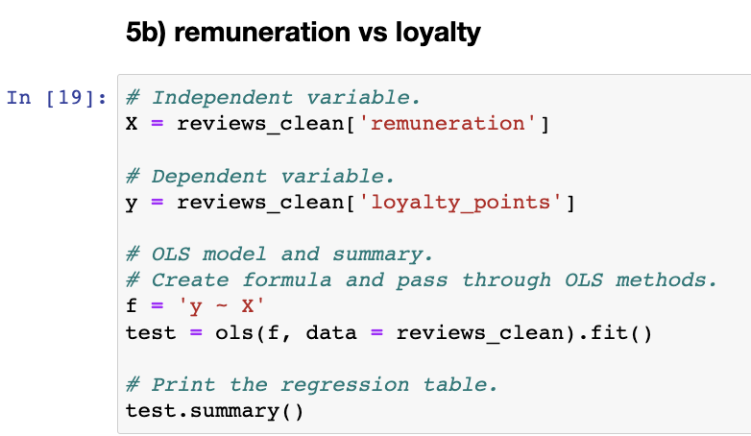

c. Age vs Loyalty Points

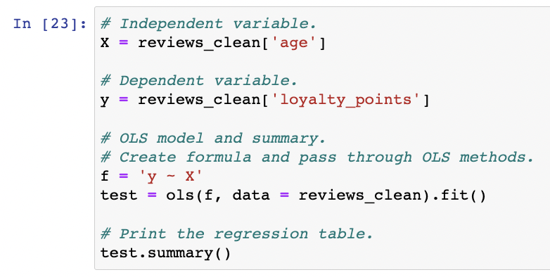

1. Linear Regression / OLS Results

a. Spending Score vs Loyalty Points

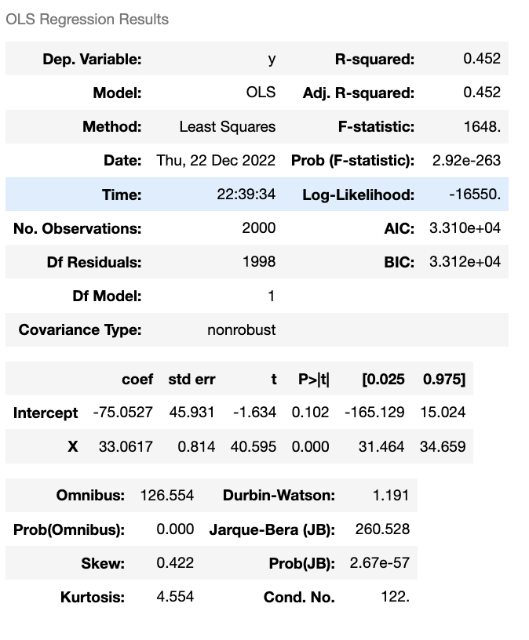

b. Remuneration vs Loyalty Points

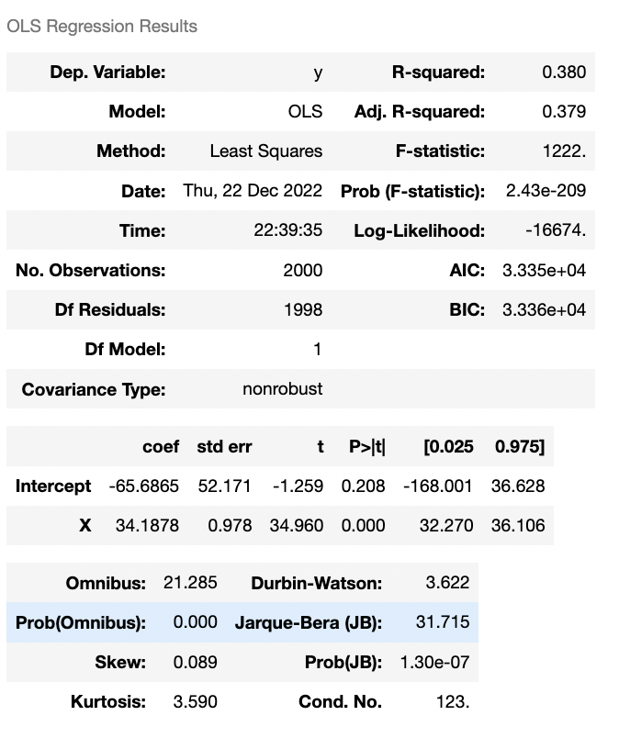

c. Age vs Loyalty Points

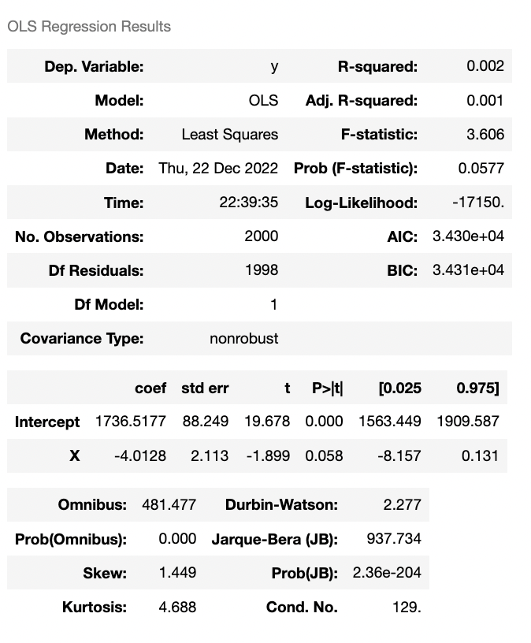

1. MLR code
2. Spending Score & Remuneration vs Loyalty Points

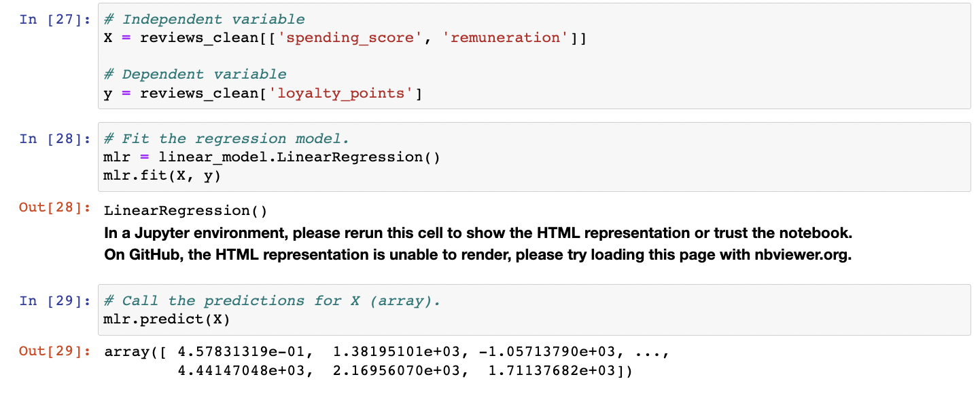

1. Spending Score, Remuneration & Age vs Loyalty Points

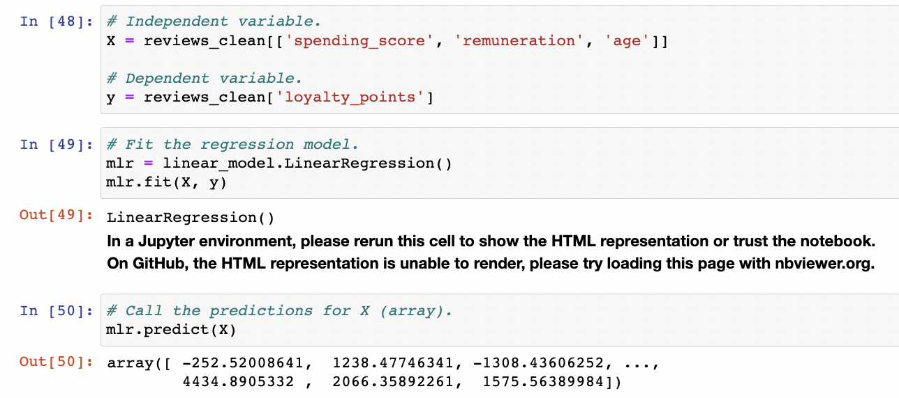

1. MLR R-Squared and Test results
2. Spending Score & Remuneration vs Loyalty Points R-squared

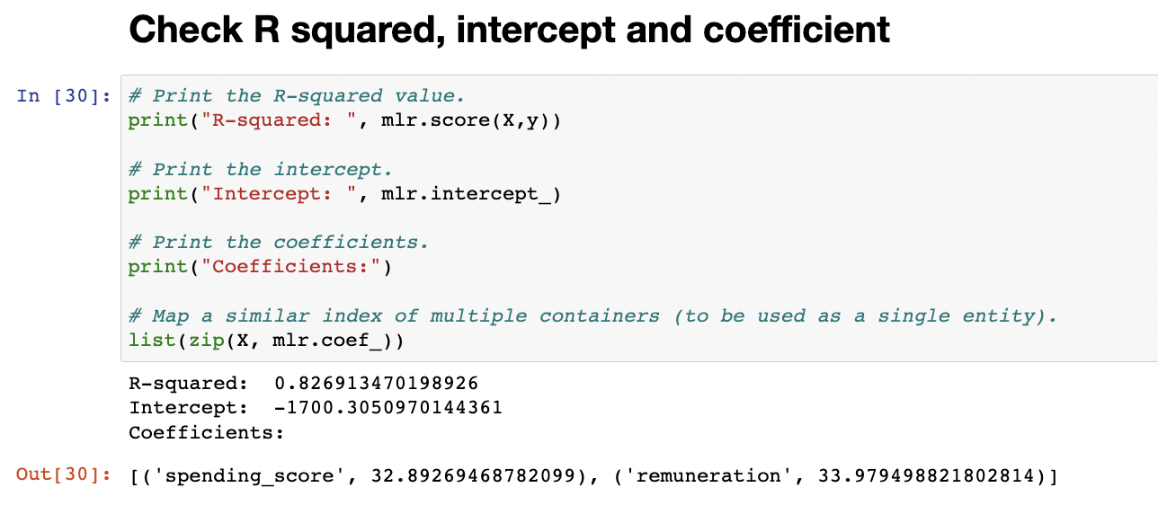

1. Spending Score & Remuneration vs Loyalty Points MLR Test results

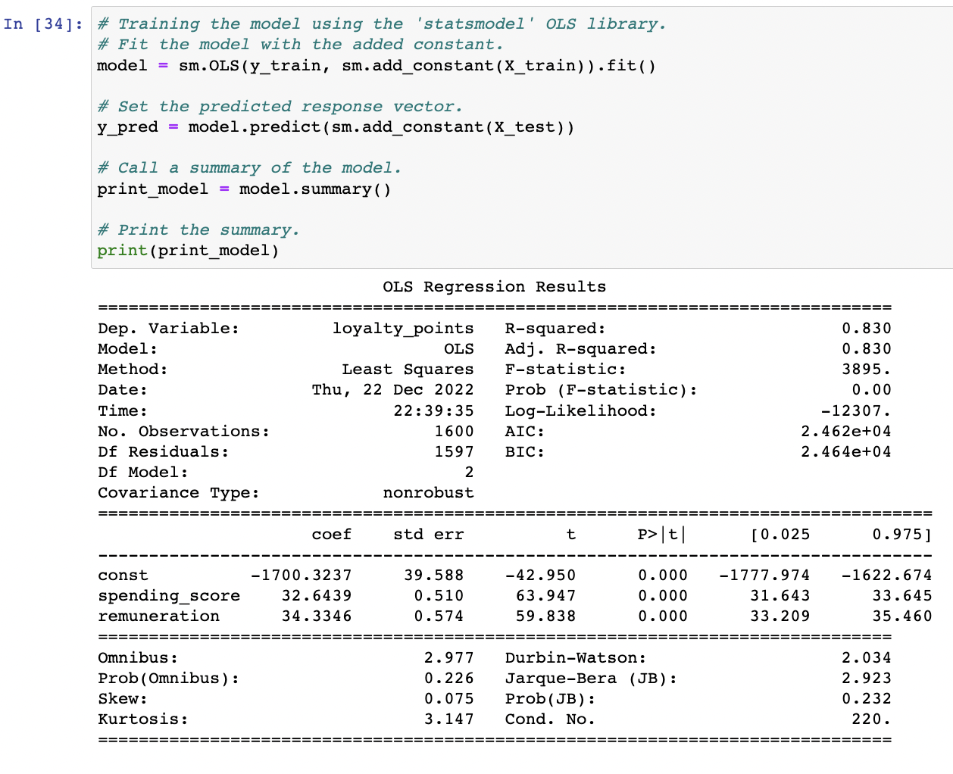

1. Spending Score, Remuneration & Age vs Loyalty Points R-squared

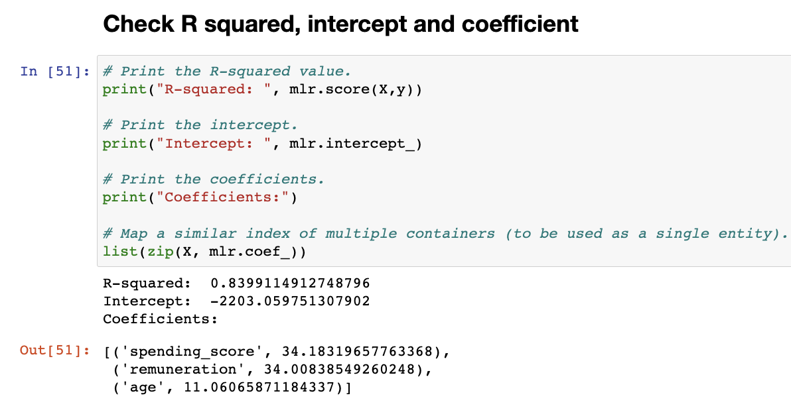

1. Spending Score, Remuneration & Age vs Loyalty Points MLR test results

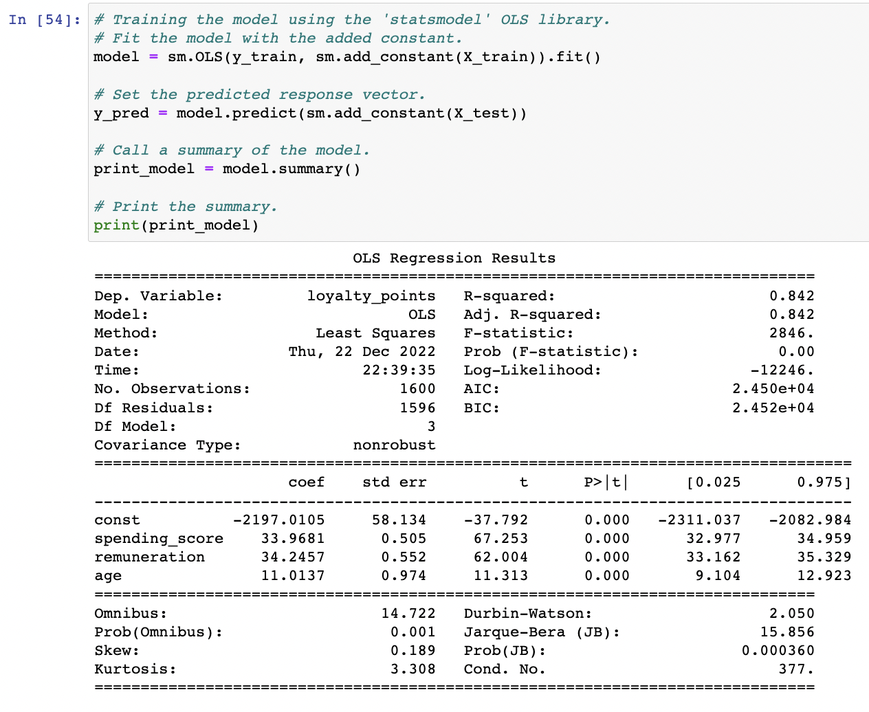

1. VIF Factor Results
2. Spending Score & Remuneration vs Loyalty Points VIF Factor

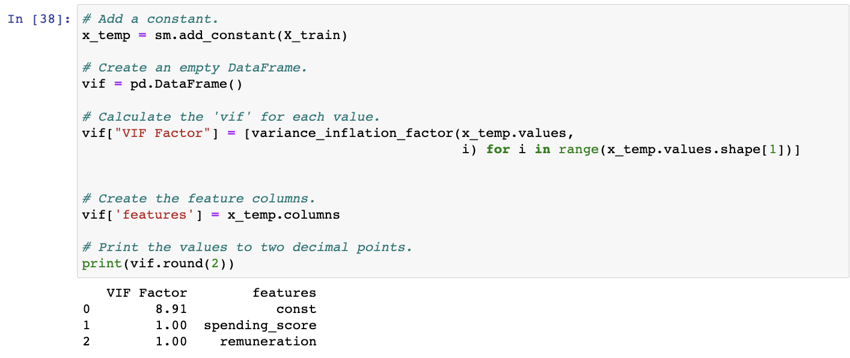

1. Spending Score, Remuneration & Age vs Loyalty Points VIF Factor Results

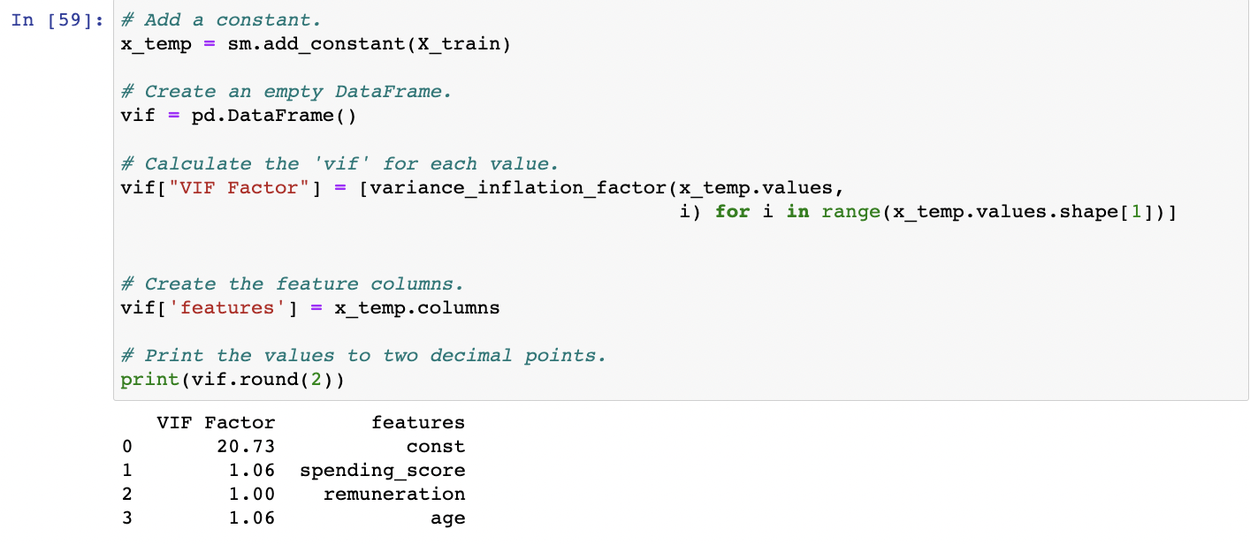

1. Clustering code snippets
2. Elbow Method

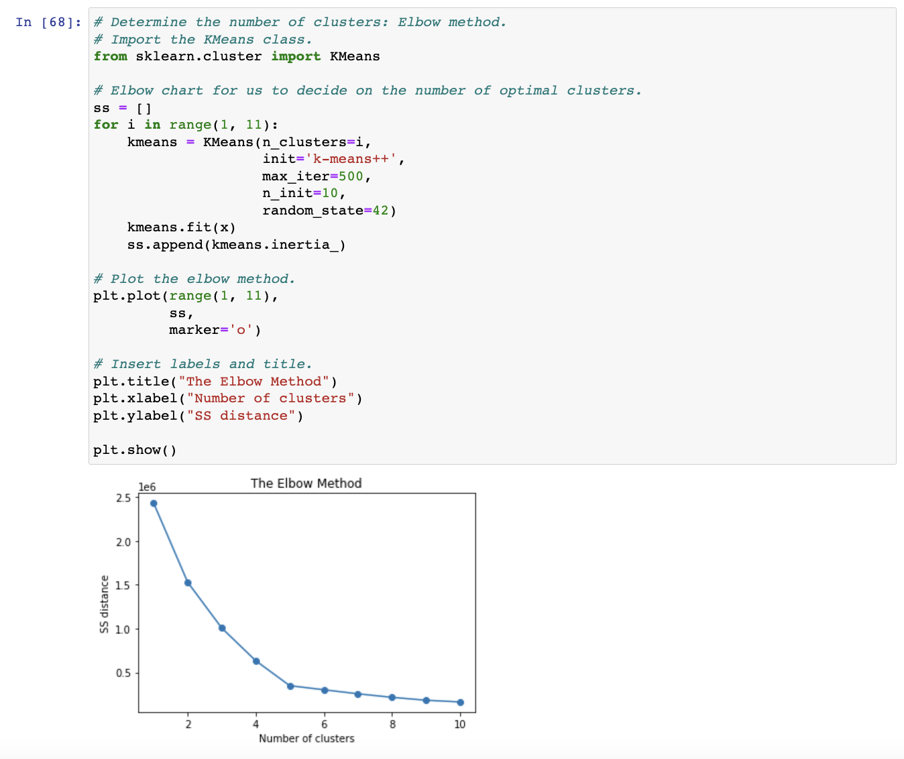

1. Silhouette Method

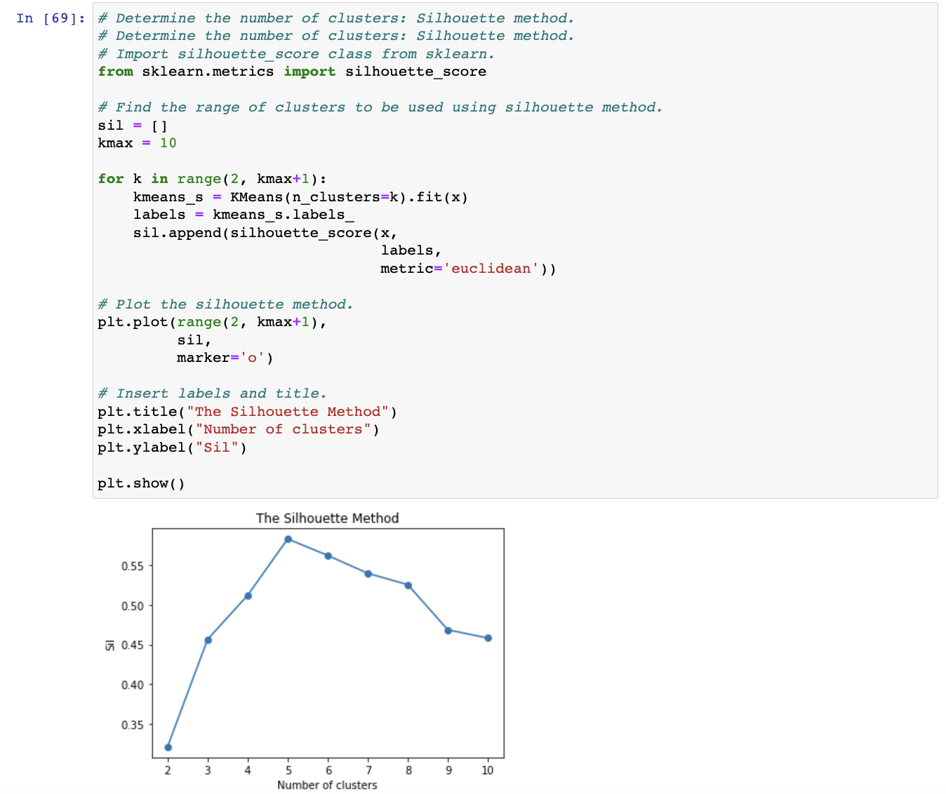

1. K-Means results
2. K = 5 code and results

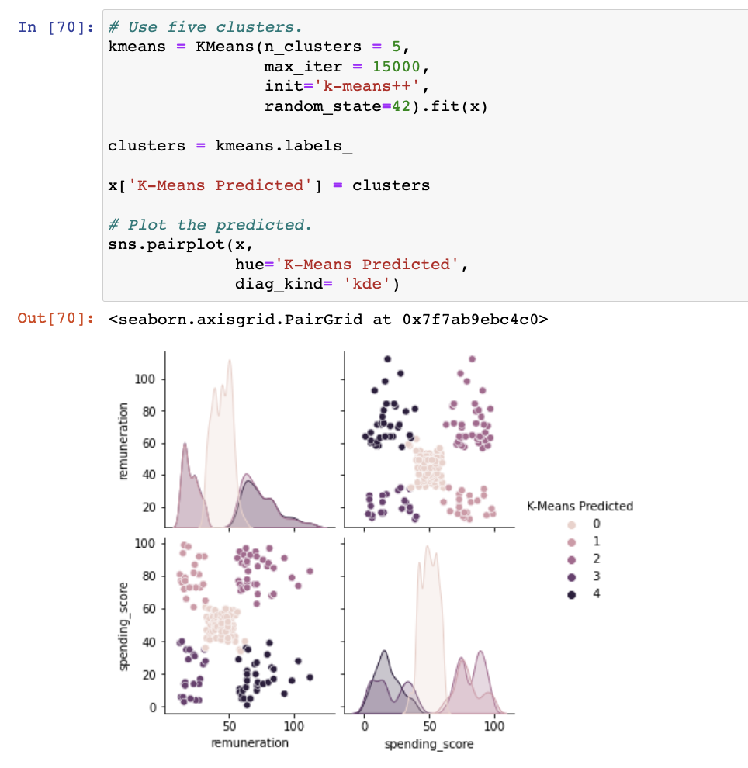

1. Clustering applied to data

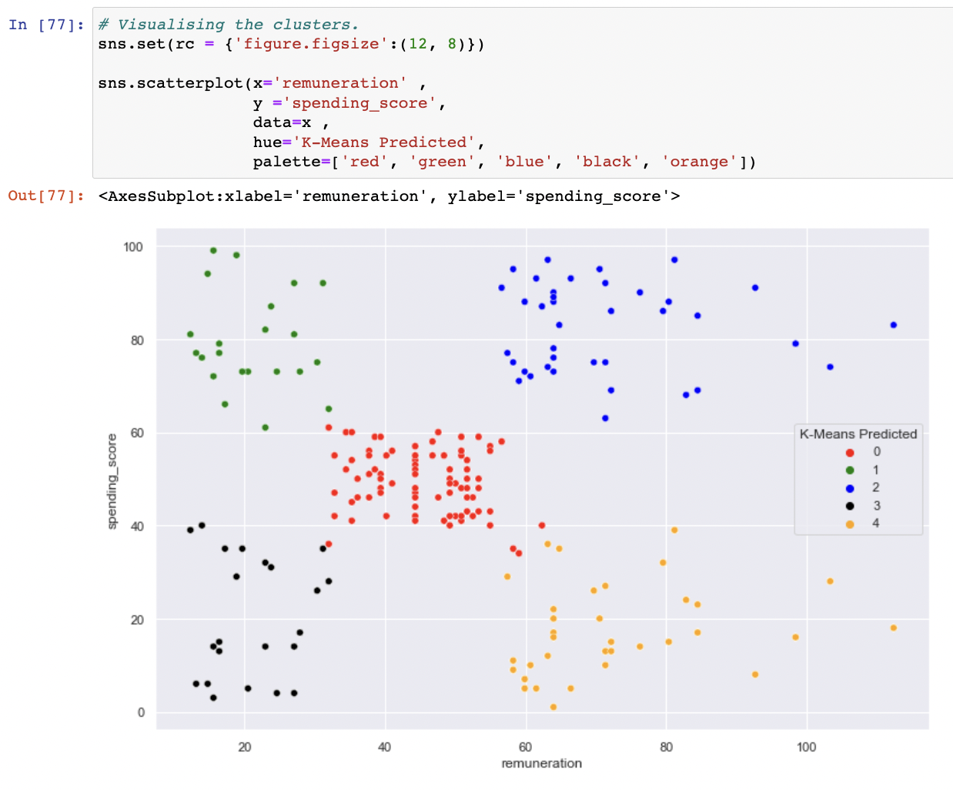

1. Cleaning data for sentiment analysis
2. Example of change to lowercase code

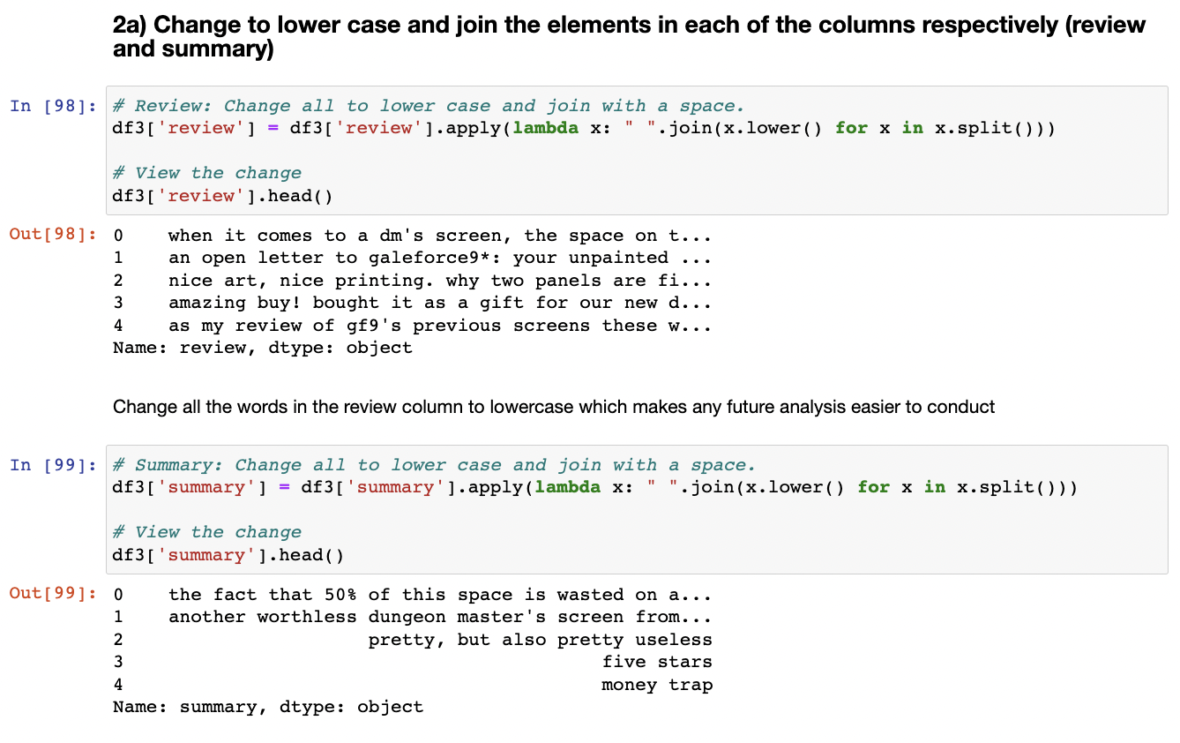

1. Example of code to remove punctuation

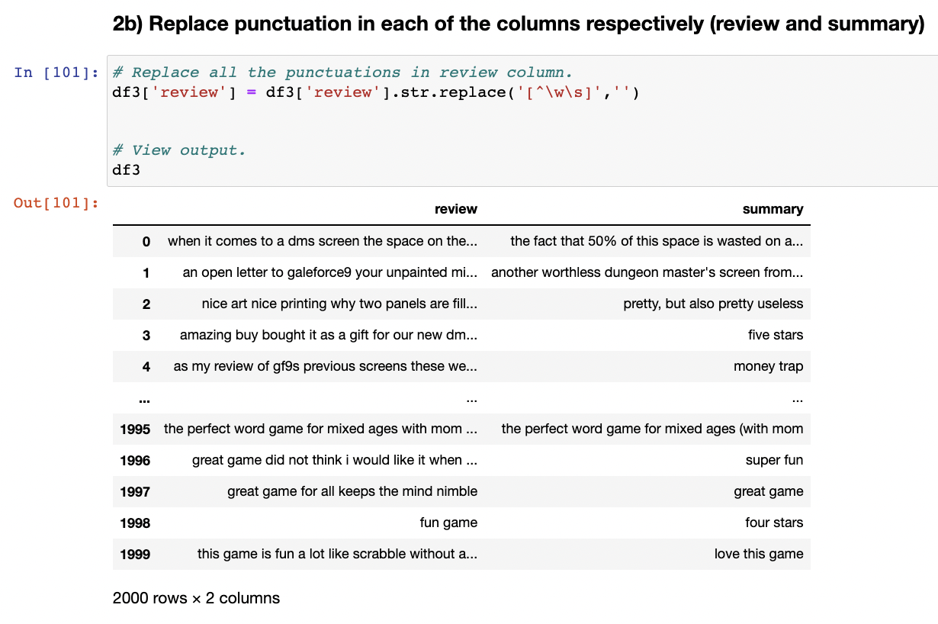

1. Code to drop duplicates

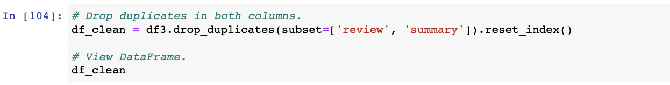

1. Code to apply tokenisation

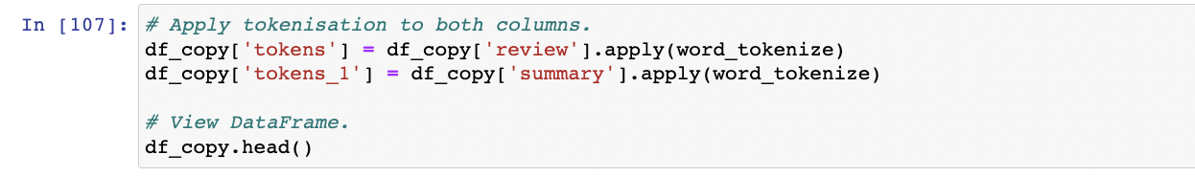

1. Sentiment analysis visualisation results
2. Reviews word cloud

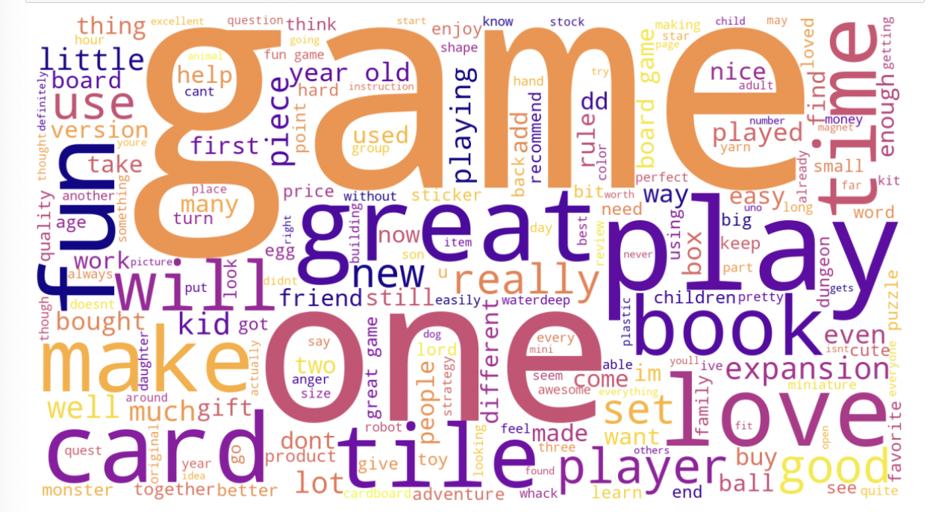

1. Summary word cloud

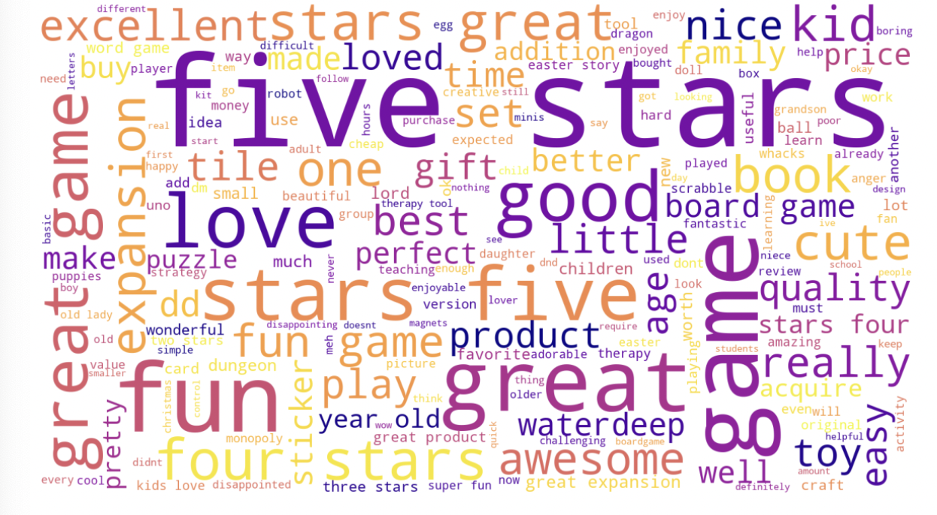

1. Review frequency distribution

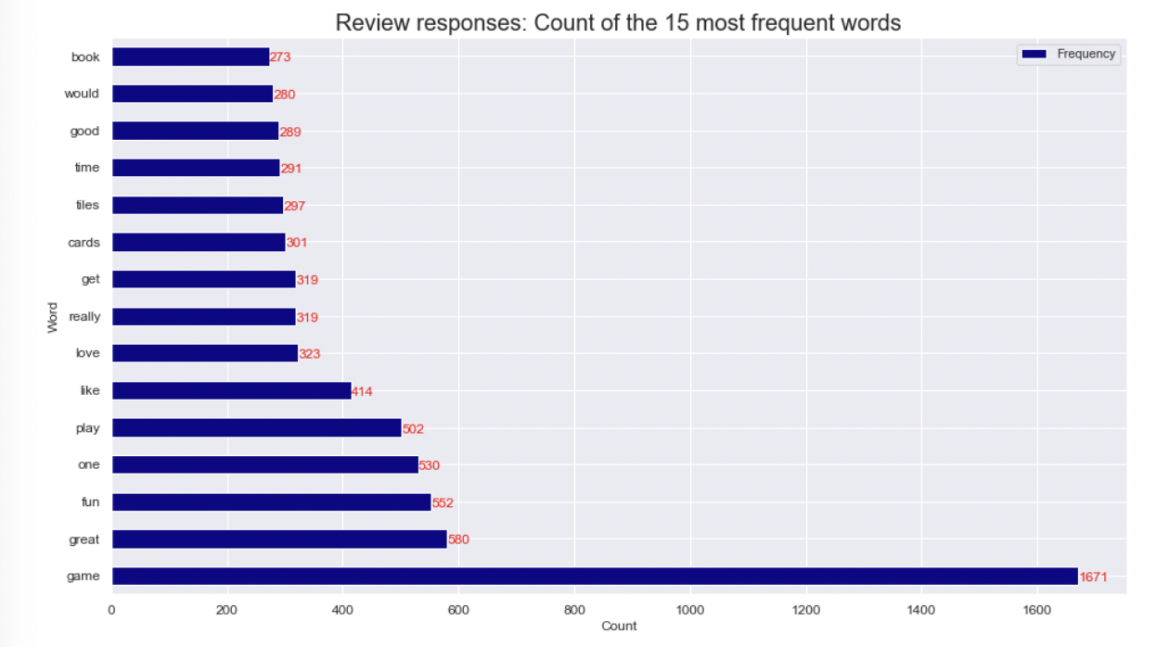

1. Summary frequency distribution

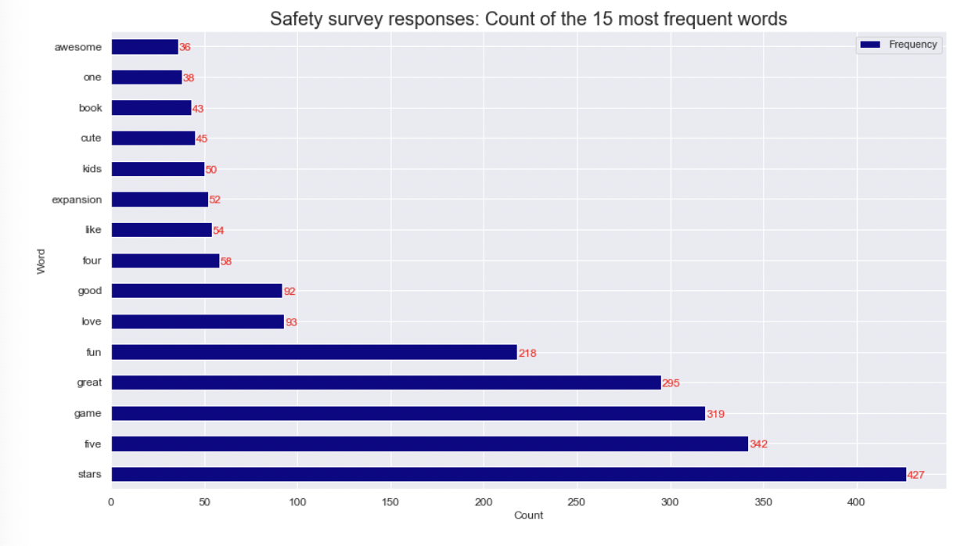

1. Q-QNorm plots
2. sum_global Q-Qnorm Plot

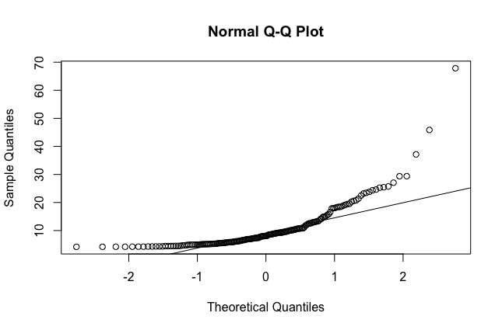

1. sum_NA Q-Qnorm plot

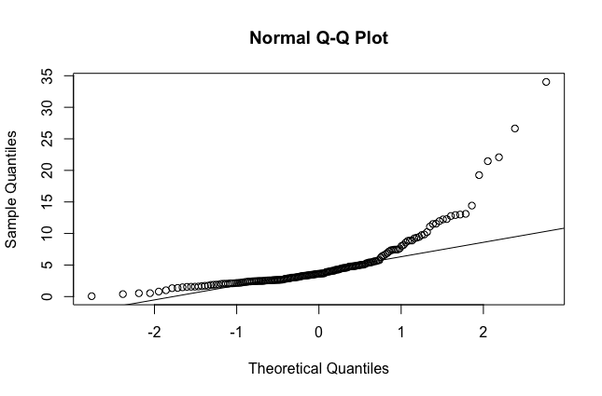

1. sum_EU Q-Qnorm plot

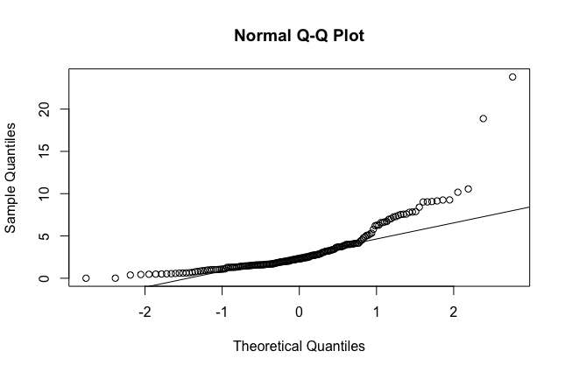

1. Shapiro Test
2. Results of Shapiro test for each aggregated sales column

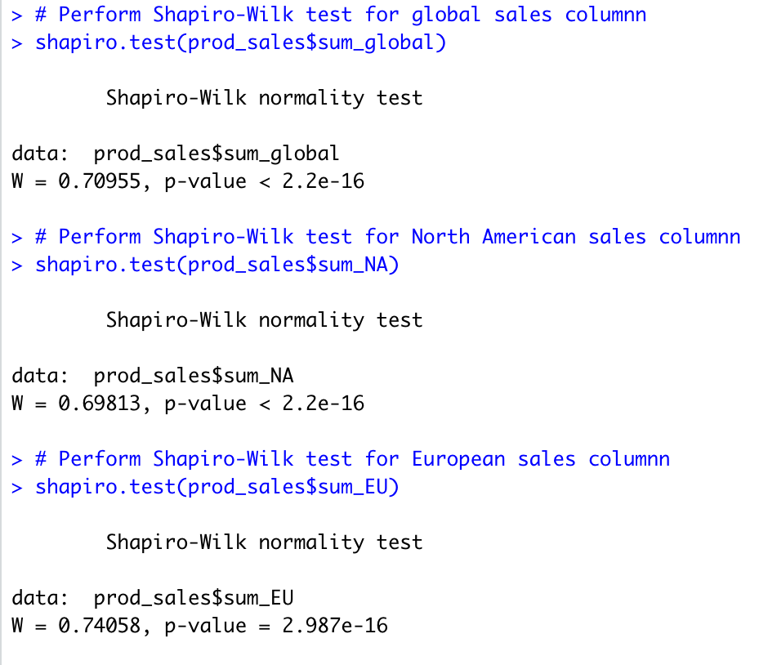

1. Skewness and Kurtosis test results
2. Skewness test results for all three columns

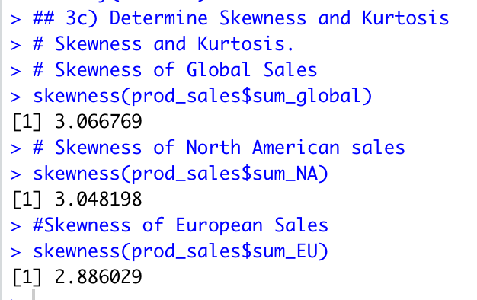

1. Kurtosis test results for all three columns

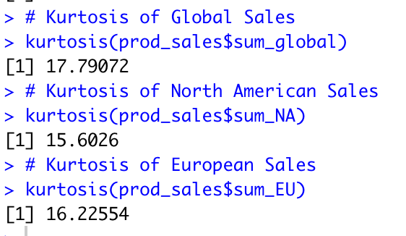

1. Linear Regression Models
2. sum_global~sum_NA

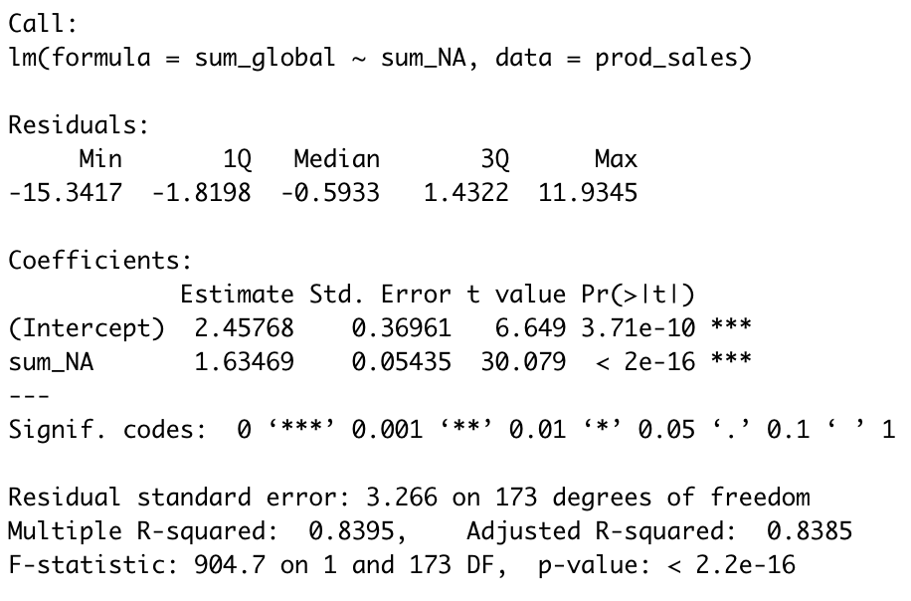

1. sum_global~sum_EU

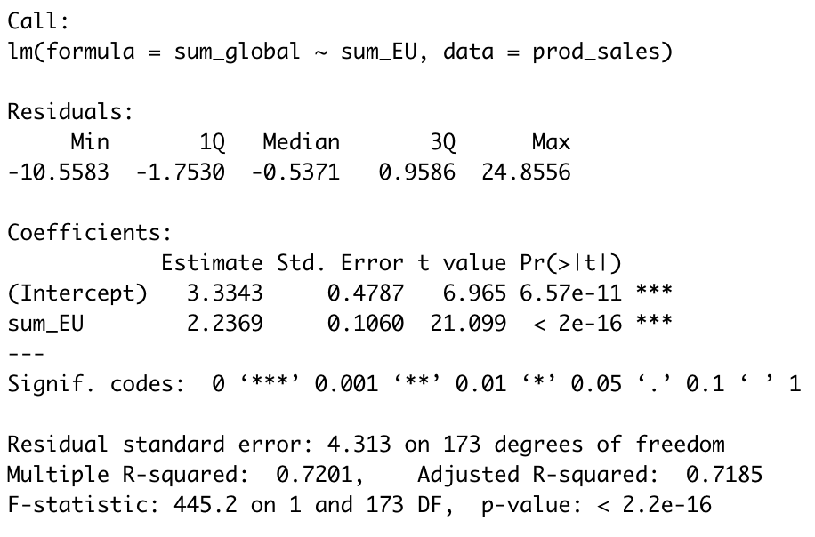

1. sum_NA~sum_EU

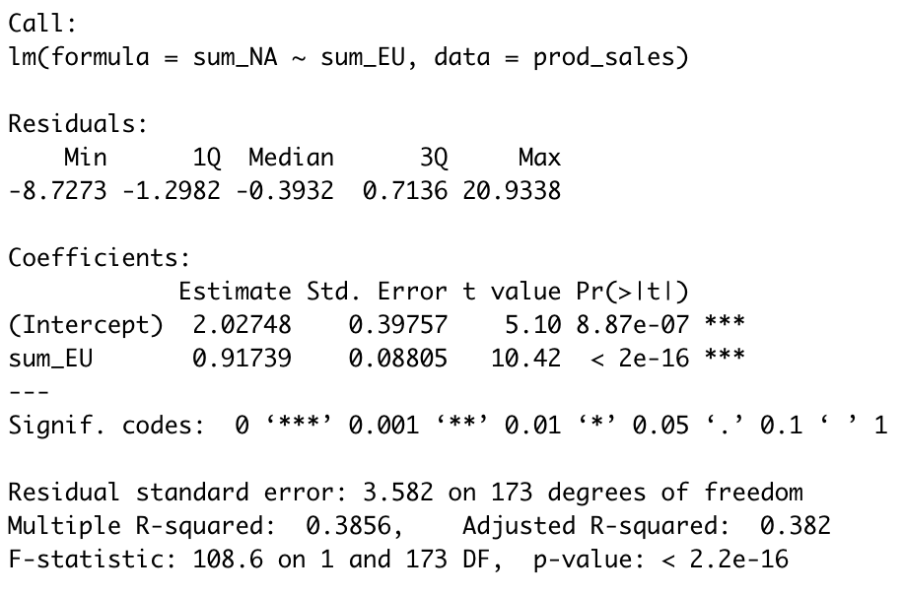

1. MLR model results
2. Global_Sales~NA_Sales+EU_Sales

